Exercicios Modulo 3:

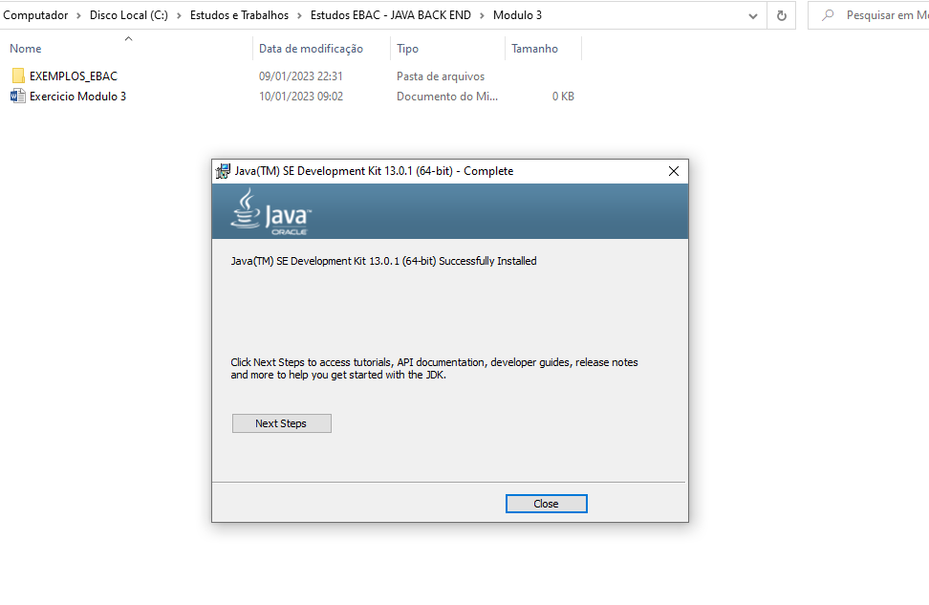

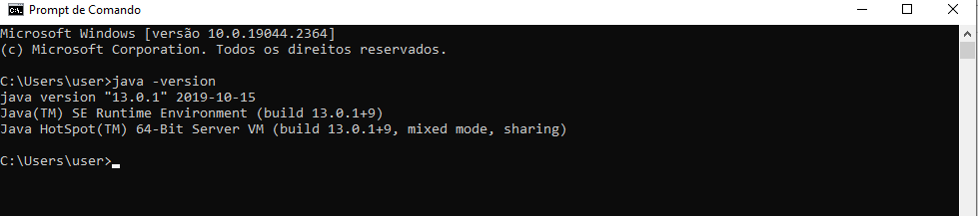

Alternativas ao JDK da Oracle são o OpenJDK (baseado no código vindo da antiga dona, Sun), Azul Platform Prime, Azul Platform Core, Red Hat OpenJDK, AdoptOpenJDK e Amazon Corretto. (fonte: [A Review of the Oracle JDK Build Alternatives - OverOps](https://www.overops.com/blog/a-review-of-the-oracle-jdk-build-alternatives/#:~:text=A%20Review%20of%20the%20Oracle%20JDK%20Build%20Alternatives,%E2%80%9CEclipse%20Adoptium%E2%80%9D%29%20...%207%207.%20Amazon%20Corretto%20)).